Project Design Phase

**Phase 4**

Project Planning

|  |  |
| --- | --- |
| Date | 27 October 2023 |
| Team ID | SI-GuidedProject-587558-1696963149 |
| Project Name | A Sleep Tracking App For A Better Night's Rest |
| Maximum Marks | 8 Marks |

Product Backlog, Sprint Schedule, and Estimation (4 Marks)

Use the below template to create product backlog and sprint schedule

|  |  |  |  |  |  |  |
| --- | --- | --- | --- | --- | --- | --- |
| **Sprint** | **Functional**  **Requirement (Epic)** | **User Story**  **Number** | **User Story / Task** | **Story**  **Points** | **Priority** | **Team**  **Members** |
| Sprint-1 | Project setup & Infrastructure | USN-1 | Set up the development environment with the required tools and frameworks to start the sleep tracking app. | 2 | High | Akshaj |
| Sprint-1 | Development environment | USN-2 | Gather necessary resources and libraries for sleep data collection and storage. | 3 | High | Armaano |
| Sprint-2 | Data collection | USN-3 | Implement data collection methods, either through user input or integration with wearable devices. | 5 | High | Akshaj |
| Sprint-2 | Data preprocessing | USN-4 | Ensure the integration with wearable devices for automatic sleep tracking is functional. | 4 | High | Pranav |
| Sprint-3 | User Data Analysis | USN-5 | Store user sleep data in a secure manner, ensuring data privacy. Begin implementing basic sleep data analysis features for insights into sleep patterns. | 3 | High | Armaano |
| Sprint-3 | User Experience Enhancement | USN-6 | Develop the user interface for the app, focusing on intuitive design and data presentation. Implement a smart alarm feature for optimized wake-up times based on sleep data. | 6 | medium | Armaano |
| Sprint-4 | Content Library | USN-7 | Create a library of calming sounds, white noise, and educational content related to sleep. | 4 | medium | Pranav |
| Sprint-5 | Testing & quality  assurance | USN-8 | Conduct thorough testing of the app to identify and report any issues or bugs. Fine-tune the app's algorithms and features based on user feedback and testing results. | 1 | medium | Akshaj |

Project Tracker, Velocity & Burndown Chart: (4 Marks)

|  |  |  |  |  |  |  |
| --- | --- | --- | --- | --- | --- | --- |
| **Sprint** | **Total Story Points** | **Duration** | **Sprint Start Date** | **Sprint End Date (Planned)** | **Story Points Completed (as on**  **Planned End Date)** | **Sprint Release Date (Actual)** |
| Sprint-1 | 5 | 1 Day | 28 Oct 2023 | 29 Oct 2023 | 27 | 9 Nov 2023 |
| Sprint-2 | 9 | 3 Days | 29 Oct 2023 | 1 Nov 2023 |  |  |
| Sprint-3 | 9 | 2 Days | 1 Nov 2023 | 3 Nov 2023 |  |  |
| Sprint-4 | 4 | 2 Days | 3 Nov 2023 | 5 Nov 2023 |  |  |
| Sprint-5 | 1 | 1 Days | 5 Nov 2023 | 6 Nov 2023 |  |  |

Velocity:

Imagine we have a 29-days sprint duration, and the velocity of the team is 20 (points per sprint). Let’s calculate the team’s average velocity (AV) per iteration unit (story points per day)

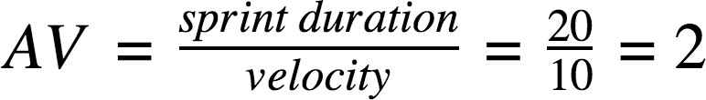

# AV= 27/10 = 2.7

Burndown Chart:

A burndown chart is a graphical representation of work left to do versus time. It is often used in agile [software development](https://www.visual-paradigm.com/scrum/what-is-agile-software-development/) methodologies such as [Scrum](https://www.visual-paradigm.com/scrum/scrum-in-3-minutes/). However, burn down charts can be applied to any project containing measurable progress over time.

<https://www.visual-paradigm.com/scrum/scrum-burndown-chart/> <https://www.atlassian.com/agile/tutorials/burndown-charts>

Reference:

<https://www.atlassian.com/agile/project-management> <https://www.atlassian.com/agile/tutorials/how-to-do-scrum-with-jira-software> <https://www.atlassian.com/agile/tutorials/epics> <https://www.atlassian.com/agile/tutorials/sprints> <https://www.atlassian.com/agile/project-management/estimation> <https://www.atlassian.com/agile/tutorials/burndown-charts>

Burndown Chart:

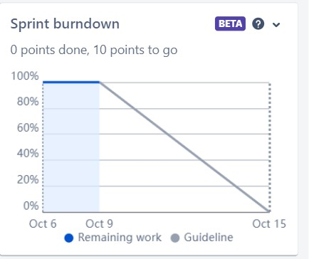

Nov 3

Oct 31

Oct 28

Board section.

We have completed sprint 1 and 2. So we can see the remaining tasks on board.

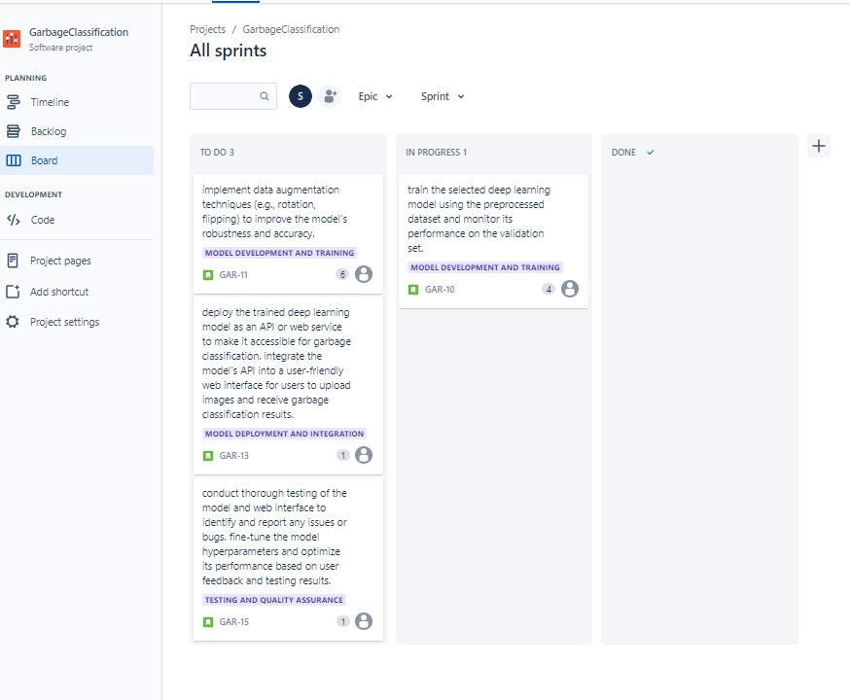

Backlog section

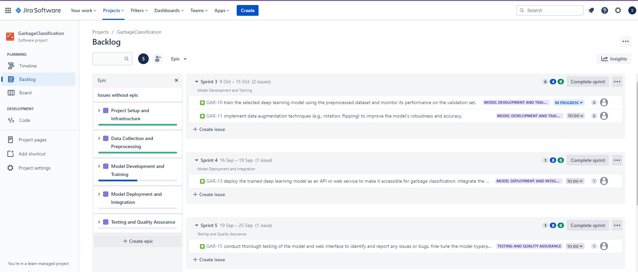

Timeline

